**A Project Report for Data Analyst Intern**

**On**

**Retail Business Performance & Profitability Analysis**

**Submitted**

**to**

**Elevate Labs**

## 

## Raju Otlam

## 1.Introduction

## The retail industry is undergoing a massive transformation driven by data analytics and business intelligence tools. With customers demanding personalized experiences and businesses striving for operational efficiency, the role of data in guiding business decisions has become more critical than ever. Retailers today gather vast amounts of data from sales transactions, customer feedback, and inventory systems yet the real value lies in analyzing this data to gain actionable insights.

## This project, Retail Business Performance & Profitability Analysis, is designed to explore and interpret retail transaction data to enhance strategic business outcomes. By studying patterns in sales, profit margins, customer preferences, and inventory movement, the analysis aims to highlight areas of strength as well as identify potential profit-draining segments. This helps stakeholders allocate resources more effectively and focus on high-impact decisions.

## The primary goal of the project is to build an interactive Power BI dashboard that visualizes key performance metrics such as total sales, profit by category, monthly revenue trends, and regional contributions. The dashboard serves as a one-stop solution for management teams to understand the business health at a glance and take necessary actions without going through raw data.

## With the use of intuitive visuals, filters, and drill-down capabilities, this report offers a modern way to approach business analysis. The ultimate aim is to empower retail businesses to optimize their operations, streamline inventory management, and maximize profitability through informed, data-driven strategies.

## 2.Abstract

## In today’s data-centric world, retail businesses are increasingly relying on analytical tools to stay competitive and profitable. Raw sales and transaction data, when properly analyzed, can uncover valuable patterns that guide better decision-making. This project focuses on analyzing a large retail dataset to uncover performance insights, using Microsoft Power BI as the primary visualization and analysis tool.

## The project involves importing transactional data, cleaning it, and building interactive dashboards that highlight critical business metrics such as profit by product category, regional sales contributions, seasonal trends, and quantity-to-profit relationships. Through visual storytelling, stakeholders can easily identify which categories are performing well, which are draining profits, and how sales fluctuate over time. Filters and slicers were added to allow dynamic exploration based on Region, Category, and Sub-Category.

## The ultimate objective is to equip decision-makers with a user-friendly dashboard that delivers real-time insights into business performance. By identifying underperforming areas and high-potential opportunities, the project demonstrates how visual analytics can drive strategic improvements in inventory management, marketing efforts, and profitability planning within the retail sector.

## 

## 3.Tools Used

## The following tools were used throughout the project:

## Microsoft Power BI Desktop: For importing, transforming, and visualizing data in interactive dashboards.

## Microsoft Excel: For reviewing and understanding the structure of the dataset.

## (Optional tools like SQL or Python were not used in this version but can be included in an advanced scope).

## Power BI’s ability to apply filters, slicers, and interactive drill-downs made it suitable for exploring large datasets visually

## 4. Steps Involved in Building the Project

## Step 1: Dataset Acquisition & Import

## The dataset was downloaded in .xlsx format.

## Imported into Power BI using “Get Data → Excel”.

## Step 2: Data Cleaning

## Handled missing/null values in critical columns like Order Date, Sales, Profit, and Region using Power BI’s Transform Data panel.

## Ensured correct data types: Dates, Numbers, and Text.

## Step 3: Creating Visualizations

## A variety of charts were created to answer key business questions:

## Line Chart: To analyze monthly sales trends and detect seasonal performance fluctuations.

## Bar Chart: For comparing profit across Sub-Categories.

## Pie & Donut Charts: Used to show regional contributions to sales.

## Scatter Plot: Correlation between quantity sold and overall profit.

## Slicers: Added for Region and Category to filter and analyze dynamically.

## Step 4: Dashboard Assembly

## All visuals were organized on a single dashboard for clear interpretation.

## Colors, titles, and formatting were adjusted for readability and impact.

## The final dashboard serves as an executive summary tool.

**5. Final Output**

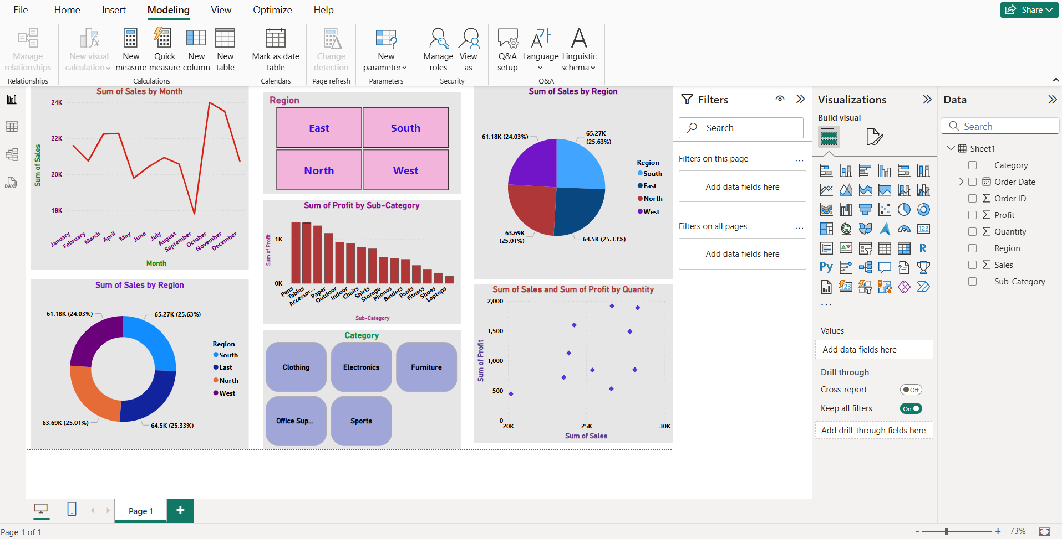

**6. Conclusion**

The Power BI dashboard successfully reveals key business insights:

* Most Profitable Categories: Technology and Office Supplies.
* Low-Performing Segments: Some Sub-Categories like Tables or Bookcases yielded lower profits.
* Regional Insights: South and West regions showed strong performance, while others needed attention.
* Inventory Optimization: The scatter plot shows that increasing quantity doesn’t always lead to higher profits—indicating potential overstock issues.

This project demonstrates the effectiveness of visual analytics in identifying actionable insights in retail. By implementing such dashboards in real-world operations, businesses can streamline strategies, improve profitability, and enhance decision-making.